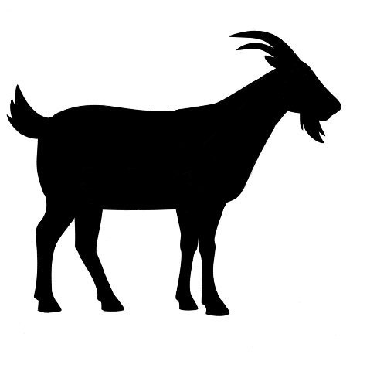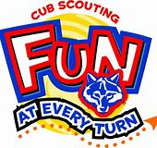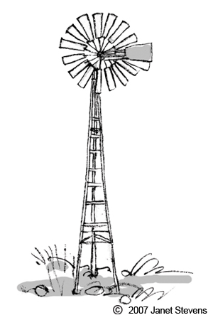

**June 17th - June 19th**

**1:00 pm - 7:00 pm**

**Durham Ferry Outdoor Education Center**

**29442 Airport Way Manteca, CA 95337**

**Program Director**

Paula Castro

aulapa56@yahoo.com

<http://www.yosemitescouting.org/camping/cub-scout-camping/cub-day-camp/51470>

Medical Check-in will be on

June 16th from 5:00 pm - 8:00 pm

Sibling Program will be available to Volunteers Only. Must be potty trained.

Each Scout will receive plenty of take home items including a patch, hat, tshirt, and bag.

Adult Volunteers who volunteer for all 3 days will receive a Tshirt, and a patch.

**Camp Director**

Cassiye Kudek

[ckudek8825@gmail.com](mailto:ckudek8825@gmail.com)

**2020**

**Sierra Valley District**

**Cub Scout Day Camp**

| Registration Deadlines | |
| --- | --- |
| Early Bird | $65.00 |
| Paid in full by May 31st |  |
| On-Time Registration | $75.00 |
| Paid in full by June 5th |  |
| Late Registration Fee | $10.00 |
| When balance paid less than 10 days before the camp begins |  |
| FOS Gold Unit Discount  when paid in full by the Early Bird Deadline | -$5.00 |