Onedrive Basic Directions

Link to all pictures
https://1drv.ms/f/s!AmnwM-i51aP9aGLuXEOdpfHoAM0

Account Management:
Log into www.onedrive.com
ID: t-110@outlook.com
PW: please see Committee Chair or Scoutmaster for password
The first link is just to see pictures, the account management link is upload pictures and manage the account.

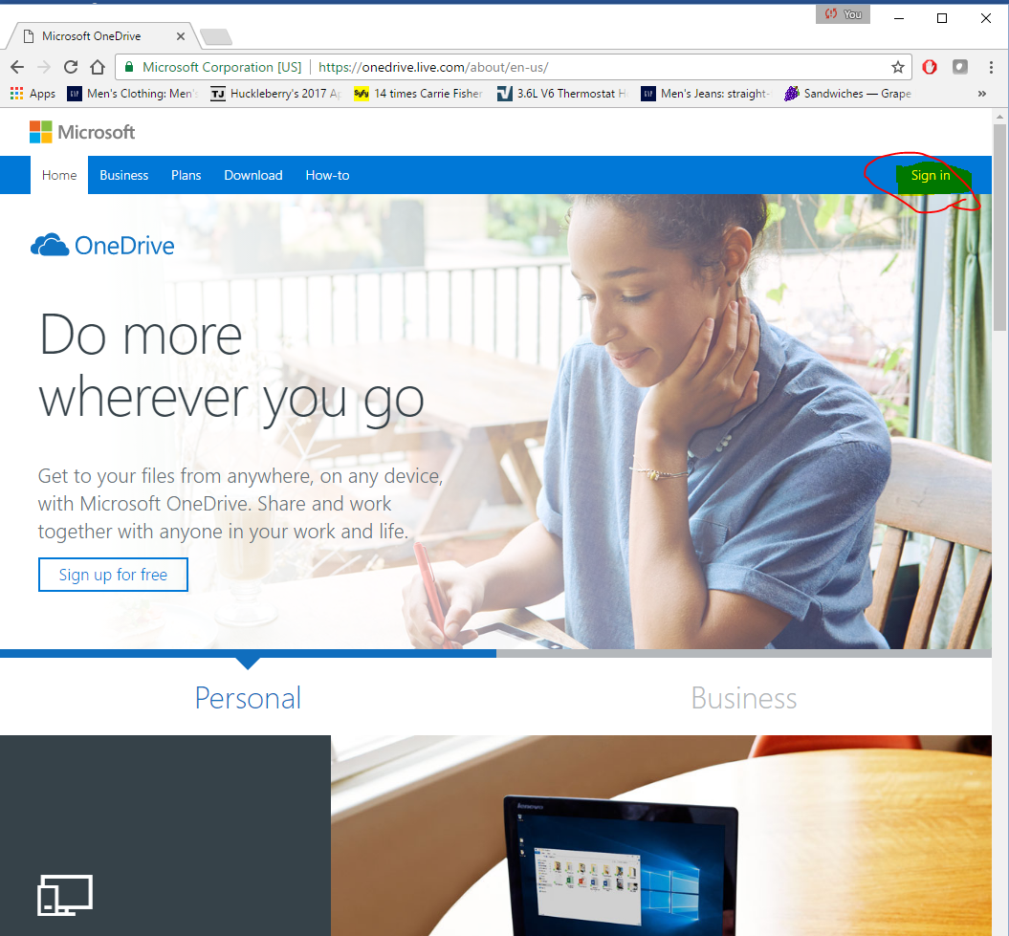
Click Sign In

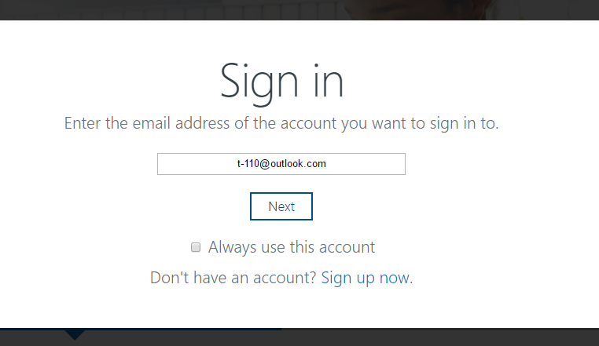
Enter Password
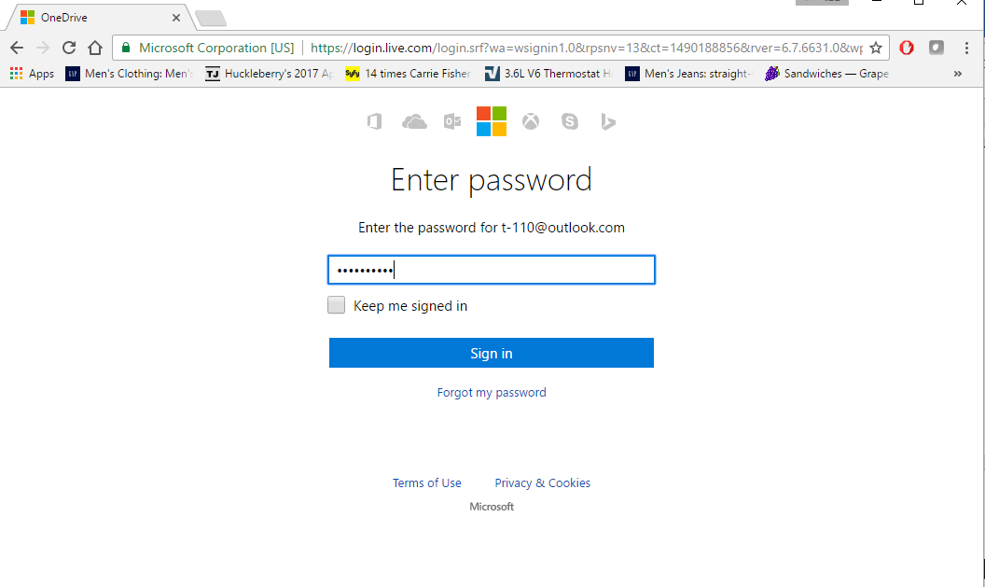
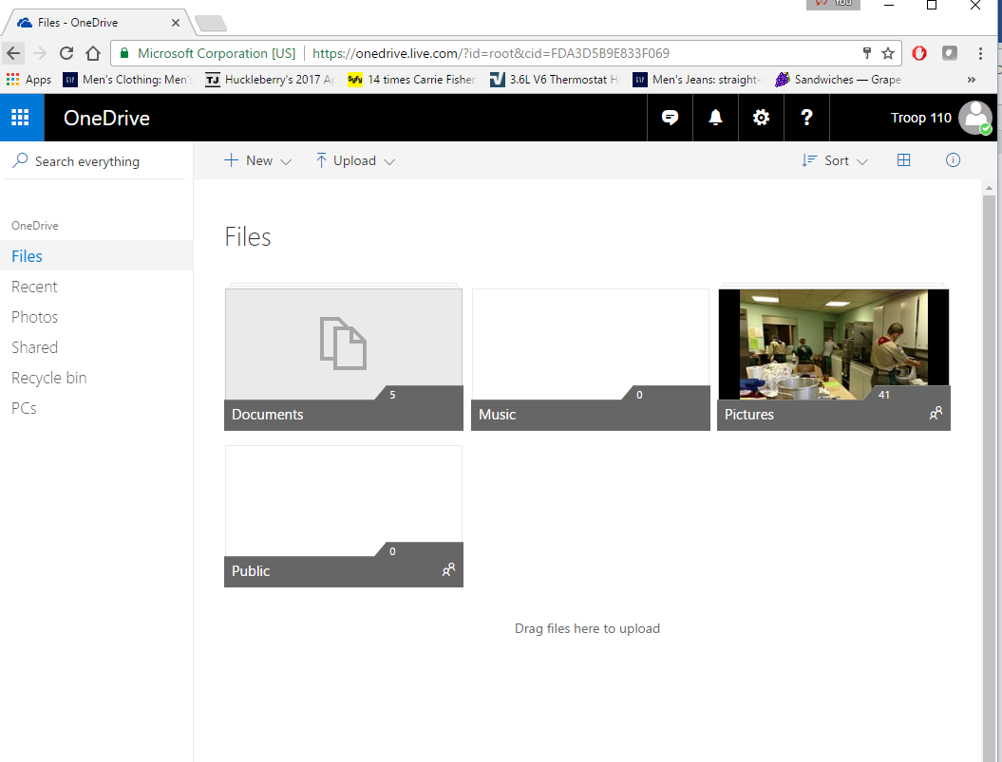
Click on the pictures folder

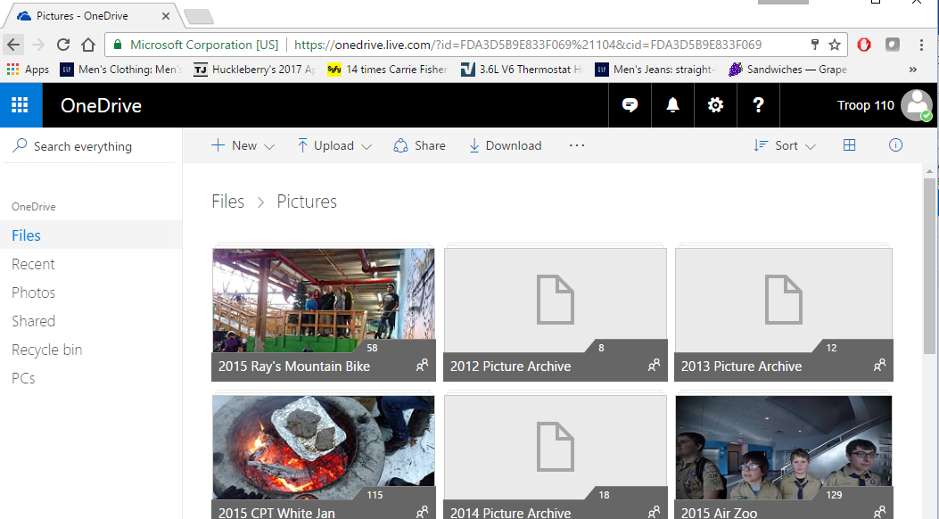
For a new event create a folder with the event name and the year of the event first. Enter the folder and click the upload button. To Share click the folder or picture and click share. To manage the account click on the upper right hand corner where it says Troop 110.

