Heroes & Helpers
Popcorn Program

Manatee County Sheriff’s Office
Sarasota Fire Department
Lee County Electric Cooperative
Collier County Veterans Council

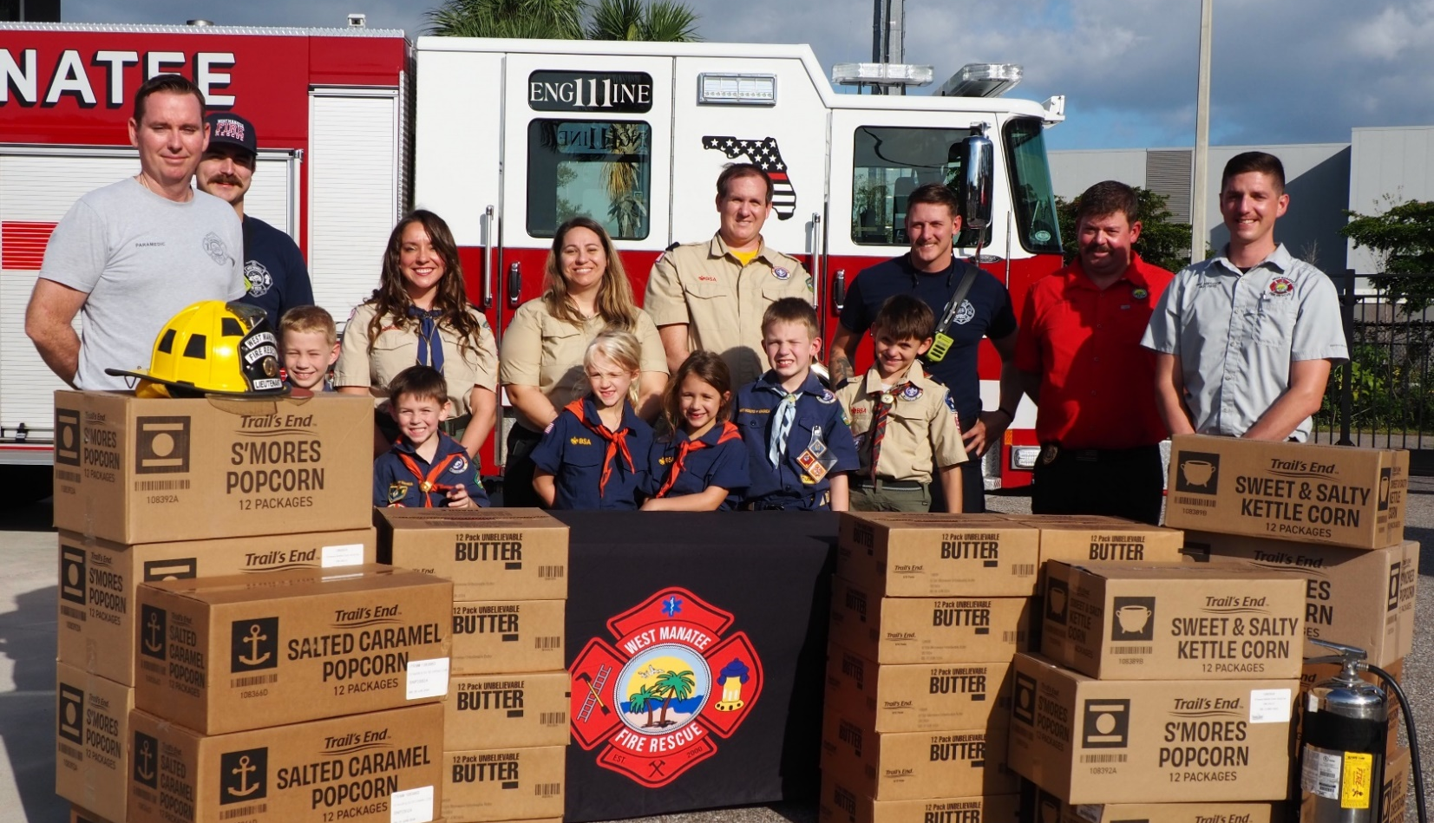

Heroes & Helpers popcorn is delivered across the local area, United States, and the world to our American Heroes & Helpers. Scouts get credit for the donations received and donors can rest assured their funds go towards multiple charitable causes. Our Scouts and Heroes THANK YOU for your donation!

