Alligator District

Webelos and Arrow of Light Scouts To Scouts BSA Social

Bridging youth to adventure!

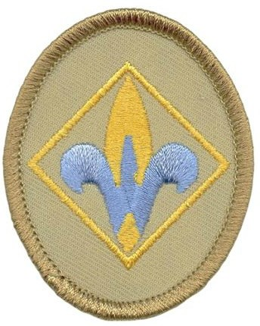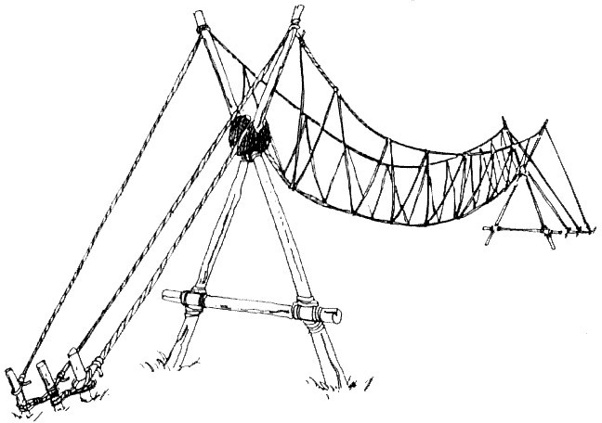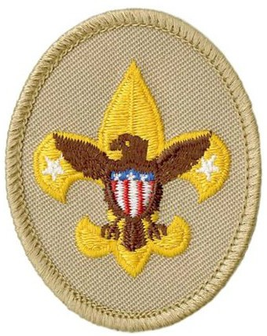

Wednesday, October 1, 2025

Moorings Presbyterian Church

791 Harbour Dr, Naples, FL 34103

Set up 6:00pm-6:30pm

Meet and Greet 6:30pm-7:30pm

# **Purpose:** To introduce Webelos & Arrow of Light Scouts and their families to Collier County Scouts BSA Troops. All Troops will have a table reserved.

**Who?:** Webelos & Arrow of Light Scouts, Parents, and Den Leaders!

**Dress:** Field Uniform

# **Contact: Ashlee O’Connor (Pack Contact) - (865) 696-6353 or ashleesams@gmail.com**

**Brian Sheridan (Troop Contact) – (630) 461 8039 or cturtle55@gmail.com**

**Webelos Leaders:** Learn the process of preparing Webelos & Arrow of Light for the cross over to Scouts BSA. Meet the Troop leaders and coordinate visits. Invite Troops to help with den and pack meetings!

**AOL Leaders:** Meet Troop leaders and schedule den visits to troop meetings or camp outs to meet the AOL rank requirements while following the Guide to Safe Scouting. Consider attending Camporee as a Den with a Troop. Please note, this event does not satisfy adventure requirements.

**Troop Leaders:** Be prepared to provide den chiefs, informational flyers, invite AOL Dens to attend Council and District events with you. Exchange contact info and have a great display!!!!! Arrive By 6PM to set up.